|  |  |
| --- | --- |
|  | Film Critic Review – Reenu Rathi |
|  |  |
|  | Msc DA  Relational Database  12/11/18 |

Table of Contents

Introduction 2

1.Table Names 3

2.Columns in Table 3

3.ERD-Entity Relationship Diagram 5

4.Extending ERD With Table Columns 6

5. Create Table Statements 7

6.Alter Table and Adding Constraint 8

7.Inserts into Tables 9

8.Tables With Populated Data 18

9. Normal Queries 22

10.Joins 24

11. SubQueries 26

12. Summary Queries 30

13. Correlated Subqueries 31

14 .Views 32

15.Union 34

16. Updates 34

# Introduction

The main aim of the study to demonstrate all the Oracle SQL syntax which we learn in class in Semester 1. We have provided the topic and tables name with the column for our study over which we need to gather the data and implement relationship between the table. After implementing the relationship between the table, we must find out the Entity Relationship Diagram (ERD) and outline the primary and foreign key in each table.

After that we need to prepare the data with the logic like how then are connected. Once the data is prepared we need to upload the data into our Oracle database i.e. we need to prepare the tables and insert the data in all those tables. After getting the data, we need to execute some queries to manipulate, retrieve data.

This document will attempt to cover these three SQL command set –

* Data Manipulation Language (DML) – SELECT, INSERT, UPDATE, DELETE, etc.
* Data Definition Language (DDL) – Create, Alter, Drop, etc.
* Grant and Revoke Commands

**Initial Question**

**Film (**Film_Id, Name, Duration, Year_Made, Cost, Lead_Role (i.e. *name of actor/actress*),Category (*Horror, Comedy etc.)*, Producer_Id)

# Critic (Critic_Id, Fname, Sname, Address, County, Gender Date_Of_Birth, Telephone_No, Mobile_No, Specialism (*Comedy, Romance, War i.e. type of movie the critic has most interest in*), Qualifications)

**Review** (Review_Id, Title, Topic, Length (i.e. *Total words*), Date_Written, Critic_Id, Film_Id, Verdict(*Terrible, Poor, Fair, Good, Excellent*), Cinema_Id (*the cinema where the critic went to watch the film before writing the review*)

**Publication** (Publication_Id, Name, Address, County, Email_Address, Web_Site,Frequency (*Daily,Weekly,Monthly*),Readership(i.e. *quantity normally sold*), Circulation (*Local, Provincial, National*), Format(*Tabloid, Broadsheet*), Selling_Price)

**Review_Publication** (Review_Id, Publication_Id, Date_Published, Reader_Feedback (*Positive, Negative, Neutral*)

**Producer** (Producer_Id, Fname, Sname, Address, City, Country, Date_Of_Birth, Year_Died (*if applicable*), Web_Site, Career_Earninngs)

**Cinema** (Cinema_Id, Name, Address, Town, County, Date_Opened, Telephone, Email, Web_Site, Capacity (i.e. *how many people it can hold)*)

**\*\*\*\*\*\*\*\*\*\*\*\*\*\*\*\*\*\*\*\*\*\*\*\*\*\*\*\*\*\*\*\*\*\*\*\*\*\*Modified\*\*\*\*\*\*\*\*\*\*\*\*\*\*\*\*\*\*\*\*\*\*\*\*\*\*\*\*\*\*\*\*\*\*\*\***

**Producer** (Producer_Id, Fname, Sname, Address, City, Country, Date_Of_Birth, Year_Died (*if applicable*), Web_Site, Career_Earninngs)

**Film (Film_id**, Name, Duration, Year_Made, Cost, Lead_Role (i.e. *name of actor/actress*),Category (*Horror, Comedy etc.)*, Producer_Id)

# Critic (Critic_Id, Fname, Sname, Address, County, Gender Date_Of_Birth, Telephone_No, Mobile_No, Specialism (*Comedy, Romance, War i.e. type of movie the critic has most interest in*), Qualifications)

**Cinema** (**Cinema_Id**, Name, Address, Town, County, Date_Opened, Telephone, Email, Web_Site, Capacity (i.e. *how many people it can hold)*)

**Review** (**Review_Id**, Title, Topic, Length (i.e. *Total words*), Date_Written, **Critic_Id**, **Film_id**, Verdict(*Terrible, Poor, Fair, Good, Excellent*), **Cinema**_**Id** (*the cinema where the critic went to watch the film before writing the review*)

**Publication** (**Publication_Id**, Name, Address, County, Email_Address, Web_Site,Frequency (*Daily,Weekly,Monthly*),Readership(i.e. *quantity normally sold*), Circulation (*Local, Provincial, National*), Format(*Tabloid, Broadsheet*), Selling_Price)

**Review_Publication** (**Review_Id**, **Publication_Id**, Date_Published, Reader_Feedback (*Positive, Negative, Neutral*)

# 1.Table Names

1. Producer
2. Film
3. Cinema
4. Critic
5. Review
6. Publication
7. Review_Publication

# 2.Columns in Table

**Producer**

|  |
| --- |
|  |
| **Producer_Id** |
| Fname |
| Sname |
| Address |
| City |
| Country |
| Date_Of_Birth |
| Year_Died |
| Web_Site |
| Career_Earninngs |

**Film**

|  |
| --- |
| **Film_Id** |
| Name |
| Duration |
| Year_Made |
| Cost |
| Lead_Role |
| Category |
| **Producer_Id** |

**Critic**

|  |
| --- |
| **Critic_Id** |
| Fname |
| Sname |
| Address |
| County |
| Gender |
| Date_Of_Birth |
| Telephone_No |
| Mobie_No |
| Specialism |
| Qualifications |

**Cinema**

|  |
| --- |
| **Cinema_Id** |
| Name |
| Address |
| Town |
| County |
| Date_Opened |
| Telephone |
| Email |
| Web_Site |
| Capacity |

**Review**

|  |
| --- |
| **Review_Id** |
| Title |
| Topic |
| Length |
| Date_Written |
| **Critic_Id** |
| **Film_Id** |
| Verdict |
| **Cinema_Id** |

**Publication**

|  |
| --- |
| **Publication_Id** |
| Name |
| Address |
| County |
| Email_Address |
| Web_Site |
| Frequency |
| Readership |
| Circulation |
| Format |
| Selling_Price |
| **Review_Publication**   |  | | --- | | **Review_Id** | | **Publication_Id** | | Date_Published | | Reader_Feedback | |

# 3.ERD-Entity Relationship Diagram

**Film Critic Review System**

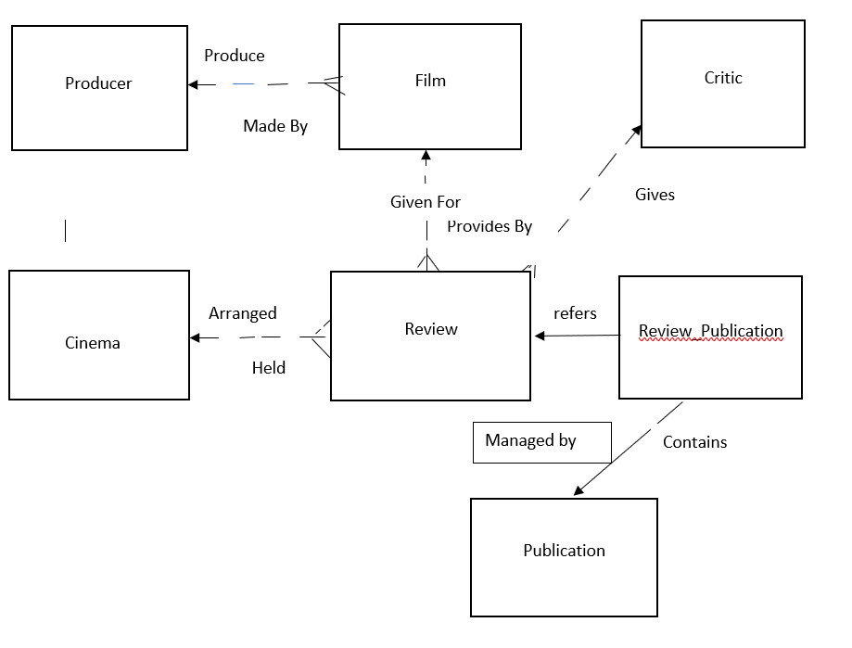

# 4.Extending ERD With Table Columns

**Film Critic Review System**

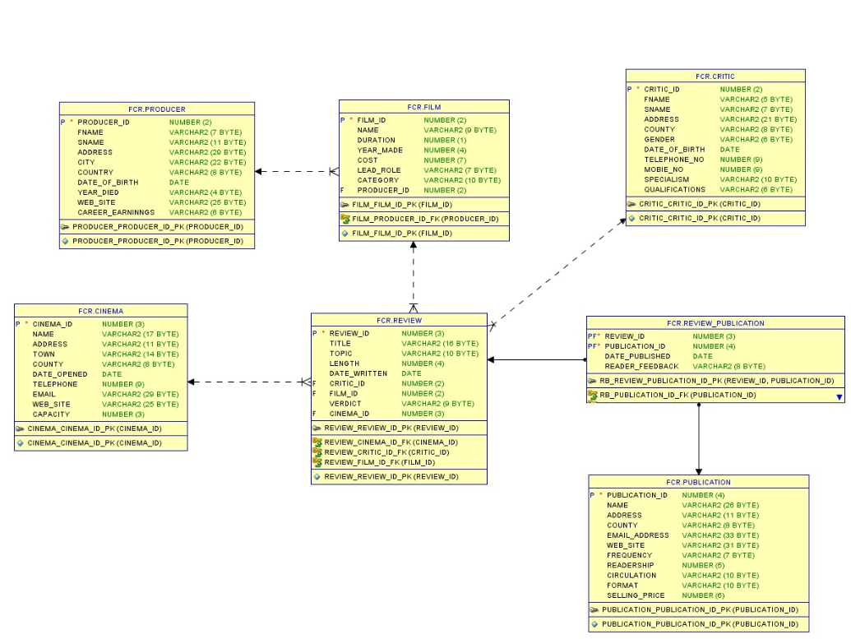

# 5. Create Table Statements

|  |  |  |  |  |  |  |
| --- | --- | --- | --- | --- | --- | --- |
| Drop Table | **Review_Publication** | **;** |  |  |  |  |
| Drop Table | **Publication** | **;** |  |  |  |  |
| Drop Table | **Review** | **;** |  |  |  |  |
| Drop Table | **Cinema** | **;** |  |  |  |  |
| Drop Table | **Critic** | **;** |  |  |  |  |
| Drop Table | **Film** | **;** |  |  |  |  |
| Drop Table | **Producer** | **;** |  |  |  |  |
|  |  |  |  |  |  |  |
| Drop Table | **Producer** | ; |  |  |  |  |
| Create Table | **Producer** | **(** |  |  |  |  |
|  | **Producer_Id** | Number | **(** | 2 | ) | , |
|  | **Fname** | Varchar2 | **(** | 7 | ) | , |
|  | **Sname** | Varchar2 | **(** | 11 | ) | , |
|  | **Address** | Varchar2 | **(** | 29 | ) | , |
|  | **City** | Varchar2 | **(** | 22 | ) | , |
|  | **Country** | Varchar2 | **(** | 8 | ) | , |
|  | **Date_Of_Birth** | Date |  |  |  | , |
|  | **Year_Died** | Varchar2 | **(** | 4 | ) | , |
|  | **Web_Site** | Varchar2 | **(** | 25 | ) | , |
|  | **Career_Earninngs** | Varchar2 | **(** | 6 | ) | ); |

|  |  |  |  |  |  |  |
| --- | --- | --- | --- | --- | --- | --- |
| Drop Table | **Film** | ; |  |  |  |  |
| Create Table | **Film** | **(** |  |  |  |  |
|  | **Film_Id** | Number | **(** | 2 | ) | , |
|  | **Name** | Varchar2 | **(** | 9 | ) | , |
|  | **Duration** | Number | **(** | 1 | ) | , |
|  | **Year_Made** | Number | **(** | 4 | ) | , |
|  | **Cost** | Number | **(** | 7 | ) | , |
|  | **Lead_Role** | Varchar2 | **(** | 7 | ) | , |
|  | **Category** | Varchar2 | **(** | 10 | ) | , |
|  | **Producer_Id** | Number | **(** | 2 | ) | ); |

|  |  |  |  |  |  |  |
| --- | --- | --- | --- | --- | --- | --- |
| Drop Table | **Critic** | ; |  |  |  |  |
| Create Table | **Critic** | **(** |  |  |  |  |
|  | **Critic_Id** | Varchar2 | **(** | 2 | ) | , |
|  | **Fname** | Varchar2 | **(** | 5 | ) | , |
|  | **Sname** | Varchar2 | **(** | 7 | ) | , |
|  | **Address** | Varchar2 | **(** | 21 | ) | , |
|  | **County** | Varchar2 | **(** | 8 | ) | , |
|  | **Gender** | Varchar2 | **(** | 6 | ) | , |
|  | **Date_Of_Birth** | Date |  |  |  | , |
|  | **Telephone_No** | Number | **(** | 9 | ) | , |
|  | **Mobie_No** | Number | **(** | 9 | ) | , |
|  | **Specialism** | Varchar2 | **(** | 10 | ) | , |
|  | **Qualifications** | Varchar2 | **(** | 6 | ) | ); |

|  |  |  |  |  |  |  |
| --- | --- | --- | --- | --- | --- | --- |
| Drop Table | **Cinema** | ; |  |  |  |  |
| Create Table | **Cinema** | **(** |  |  |  |  |
|  | **Cinema_Id** | Number | **(** | 3 | ) | , |
|  | **Name** | Varchar2 | **(** | 17 | ) | , |
|  | **Address** | Varchar2 | **(** | 11 | ) | , |
|  | **Town** | Varchar2 | **(** | 14 | ) | , |
|  | **County** | Varchar2 | **(** | 8 | ) | , |
|  | **Date_Opened** | Date |  |  |  | , |
|  | **Telephone** | Number | **(** | 9 | ) | , |
|  | **Email** | Varchar2 | **(** | 29 | ) | , |
|  | **Web_Site** | Varchar2 | **(** | 25 | ) | , |
|  | **Capacity** | Number | **(** | 3 | ) | ); |

|  |  |  |  |  |  |  |
| --- | --- | --- | --- | --- | --- | --- |
| Drop Table | **Review** | ; |  |  |  |  |
| Create Table | **Review** | ( |  |  |  |  |
|  | **Review_Id** | Number | **(** | 3 | ) | , |
|  | **Title** | Varchar2 | **(** | 16 | ) | , |
|  | **Topic** | Varchar2 | **(** | 10 | ) | , |
|  | **Length** | Number | **(** | 4 | ) | , |
|  | **Date_Written** | Date |  |  |  | , |
|  | **Critic_Id** | Varchar2 | **(** | 2 | ) | , |
|  | **Film_Id** | Varchar2 | **(** | 2 | ) | , |
|  | **Verdict** | Varchar2 | **(** | 9 | ) | , |
|  | **Cinema_Id** | Varchar2 | **(** | 3 | ) | ); |

|  |  |  |  |  |  |  |
| --- | --- | --- | --- | --- | --- | --- |
| Drop Table | **Publication** | ; |  |  |  |  |
| Create Table | **Publication** | ( |  |  |  |  |
|  | **Publication_Id** | Number | **(** | 4 | ) | , |
|  | **Name** | Varchar2 | **(** | 26 | ) | , |
|  | **Address** | Varchar2 | **(** | 11 | ) | , |
|  | **County** | Varchar2 | **(** | 8 | ) | , |
|  | **Email_Address** | Varchar2 | **(** | 33 | ) | , |
|  | **Web_Site** | Varchar2 | **(** | 31 | ) | , |
|  | **Frequency** | Varchar2 | **(** | 7 | ) | , |
|  | **Readership** | Number | **(** | 5 | ) | , |
|  | **Circulation** | Varchar2 | **(** | 10 | ) | , |
|  | **Format** | Varchar2 | **(** | 10 | ) | , |
|  | **Selling_Price** | Number | **(** | 6 | ) | ); |

|  |  |  |  |  |  |  |
| --- | --- | --- | --- | --- | --- | --- |
| Drop Table | **Review_Publication** | ; |  |  |  |  |
| Create Table | **Review_Publication** | ( |  |  |  |  |
|  | **Review_Id** | Number | **(** | 3 | ) | , |
|  | **Publication_Id** | Number | **(** | 4 | ) | , |
|  | **Date_Published** | Date |  |  |  | , |
|  | **Reader_Feedback** | Varchar2 | **(** | 8 | ) | ); |

# 6.Alter Table and Adding Constraint

**--primary keys (PK)**

Alter table Producer Add constraint Producer_Producer_Id_Pk Primary Key (Producer_Id);

Alter table Film Add constraint Film_Film_Id_Pk Primary Key (Film_Id) ;

Alter table Critic Add constraint Critic_Critic_Id_Pk Primary Key (Critic_Id);

Alter table Cinema Add constraint Cinema_Cinema_Id_Pk Primary Key (Cinema_Id);

Alter table Review Add constraint Review_Review_Id_Pk Primary Key (Review_Id);

Alter table Publication Add constraint Publication_Publication_Id_Pk Primary Key (Publication_Id);

Alter table Review_Publication Add constraint RB_Review_Publication_Id_Pk Primary Key (Review_Id,Publication_Id);

**-- Foreign Keys (FK)**

Alter table Film Add constraint Film_Producer_Id_Fk Foreign Key (Producer_Id) references Producer(Producer_Id);

Alter table Review Add constraint Review_Critic_Id_Fk Foreign Key (Critic_Id) references Critic (Critic_Id);

Alter table Review Add constraint Review_Cinema_Id_Fk Foreign Key (Cinema_Id) references Cinema (Cinema_Id);

Alter table Review Add constraint Review_Film_Id_Fk Foreign Key (Film_Id) references Film(Film_Id);

Alter table Review_Publication Add constraint RB_Review_Id_Fk Foreign Key (Review_Id) references Review(Review_Id);

Alter table Review_Publication Add constraint RB_Publication_Id_Fk Foreign Key (Publication_Id) references Publication(Publication_Id);

**-- Check Constraints (CK)**

Alter table Film Add constraint Film_Lead_Role_Ck check (Lead_Role In ('Actor', 'Actress', 'Villian'));

Alter table Film Add constraint Film_Category_Ck check (Category In ('Comady','Horror','Art','Historical','Romance'));

Alter table Critic Add constraint Critic_Specialism_Ck check (Specialism In ('Comady', 'Horror', 'Art', 'Historical', 'Romance', 'War'));

Alter table Review Add constraint Review_Verdict_Quality_Ck check (Verdict In ('Terrible', 'Good', 'Poor', 'Excellent', 'Fair')) ;

Alter table Publication Add constraint Publication_Frequency_Ck check (Frequency In ('Monthly', 'Daily', 'Weekly'));

Alter table Publication Add constraint Publication_Circulation_Ck check (Circulation In ('Local', 'National', 'Provincial'));

Alter table Publication Add constraint Publication_Format_Ck check (Format In ('Broadsheet', 'Tabloid')) ;

Alter table Review_Publication Add constraint RB_Reader_Feedback_Ck check (Reader_Feedback In ('Positive', 'Negative', 'Neutral'));

**-- Unique Constraints (UQ)**

Alter table Produceer Add constraint Producer_Web_Site_Uq unique ( Web_Site );

Alter table Critic Add constraint Critic_Mobile_No_Uq unique ( Mobie_No );

Alter table Cinema Add constraint Cinema_Email_Uq unique ( Email ) ;

Alter table Cinema Add constraint Cinema_Web_Site_Uq unique ( Web_Site );

Alter table Cinema Add constraint Cinema_Telephone_Uq unique ( Telephone );

Alter table Critic Add constraint Critic_Telephone_No_Uq unique ( Telephone_No ) ;

Alter table Publication Add constraint Publication_Web_Site_Uq unique ( Web_Site );

**-- Not Null Constraints (NN)**

Alter table Producer Modify Fname Constraint Producer_Fname_Nn Not Null ;

Alter table Producer Modify Sname Constraint Producer_Sname_Nn Not Null ;

Alter table Critic Modify Fname Constraint Critic_Fname_Nn Not Null ;

Alter table Critic Modify Sname Constraint Critic_Sname_Nn Not Null ;

Alter table Film Modify Name Constraint Film_Name_Nn Not Null ;

Alter table Cinema Modify Name Constraint Cinema_Name_Nn Not Null ;

# 7.Inserts into Tables

**/* Table Name:Producer */**

/*Producer_Id,Fname,Sname,Address,City,Country,Date_Of_Birth,Year_Died,Web_Site,Career_Earninngs */

Insert Into Producer Values (10,'Damier','Diver','1º Mayo','Santa Cruz de Tenerife','Cavan','01-Feb-64',2015,'www.dmie.com',200000);

Insert Into Producer Values (12,'Noel','Hegarty','39 -3 Ayamonte-Huelva','Oviedo','Mayo','24-Jan-77',2016,'www.noel.com',250000);

Insert Into Producer Values (14,'Noel','McGinley','29651 Málaga','Vitoria','Offaly','14-Dec-71',2010,'www.Gunn.com',300000);

Insert Into Producer Values (16,'Ollie','Reid','4 Gernika-Lumo','Elx','Monaghan','28-Nov-76',2012,'www.ollie.com',350000);

Insert Into Producer Values (18,'James','Ruane','callede Franklin Benjamín 34','Madrid','Cork','12-Feb-73',2010,'www.jjms.com',200000);

Insert Into Producer Values (20,'Raymond','Sweeney','Ctra. del Rincón, 29','Barcelona','Derry','18-Mar-78',2015,'www.raymond.com',250000);

Insert Into Producer Values (22,'Tony','Boyle','17 - A Riouxa','Santa Cruz de Tenerife','Cavan','28-Jan-59',2016,'www.ubertech.com',300000);

Insert Into Producer Values (24,'Brendan','Devenney','3 Vigo-Pontevedra','Oviedo','Mayo','24-Nov-67',2010,'www.nixs.com',350000);

Insert Into Producer Values (26,'Andrew','Gallagher','Ctra. del Rincón, 29','Barcelona','Derry','02-Dec-66',2011,'www.ajnara.com',180000);

Insert Into Producer Values (28,'James','Gallagher','Carlos Egea Krauel 13-14','Elx','Monaghan','18-Jan-59',2006,'www.ajanta.com',300000);

Insert Into Producer Values (30,'John','Gildea','5, Retreat Road','Madrid','Cork','23-Feb-69',2008,'www.republic.com',320000);

Insert Into Producer Values (32,'Michael','Hegarty','19, Croi Oige','Barcelona','Derry','14-Feb-78',2013,'www.goalby.com',330000);

Insert Into Producer Values (34,'Brian','Roper','7, Glen','Donostia','Cavan','28-Jan-56',2010,'www.chichi.com',300000);

Insert Into Producer Values (36,'Adrian','Sweeney','88, Malwani','Vitoria','Monaghan','24-Nov-77',2017,'www.ambani.com',280000);

Insert Into Producer Values (38,'Tony','Blake','254, Proper Road','Valencia','Offaly','02-Dec-56',2007,'www.redchilly.com',250000);

Insert Into Producer Values (40,'Paul','Callaghan','1º Mayo','Santa Cruz de Tenerife','Cavan','18-Jan-57',2016,'www.kkprod.com',280000);

Insert Into Producer Values (42,'J','Friel','39 -3 Ayamonte-Huelva','Oviedo','Mayo','23-Feb-67',2009,'www.brprod.com',250000);

Insert Into Producer Values (44,'Jim','McGuinness','29651 Málaga','Vitoria','Offaly','14-Feb-77',2006,'www.everymove.com',280000);

Insert Into Producer Values (46,'Brian','McLoughlin','4 Gernika-Lumo','Elx','Monaghan','18-Mar-78',2012,'www.Logics.com',330000);

Insert Into Producer Values (48,'Ciaran','Byrne','1 - Local Las Tablas','Vitoria','Offaly','28-Jan-66',2013,'www.avg.com',320000);

**/* Table Name:Film */**

/*Film_Id,Name,Duration,Year_Made,Cost,Lead_Role,Category,Producer_Id */

Insert Into Film Values (9,'Avatar',3,2006,1114601,'Actor','Horror',10);

Insert Into Film Values (11,'Avenger',3,2008,2724274,'Actor','Comady',12);

Insert Into Film Values (13,'Lagaan',3,2009,2374378,'Actor','Romance',14);

Insert Into Film Values (15,'Quantico',3,2000,2020938,'Actor','Art',16);

Insert Into Film Values (17,'Suits',3,2006,2486331,'Actor','Historical',18);

Insert Into Film Values (19,'Two And Half Man',3,2000,1853992,'Actor','Horror',20);

Insert Into Film Values (21,'Sacred Games',3,2016,1164960,'Actor','Comady',22);

Insert Into Film Values (23,'Holy Games',2,2008,1652506,'Actor','Romance',24);

Insert Into Film Values (25,'Halloween',2,2010,1181630,'Actress','Art',26);

Insert Into Film Values (27,'Padman',2,2016,2784989,'Actress','Historical',28);

Insert Into Film Values (29,'Padmavat',2,2016,1525793,'Actress','Horror',30);

Insert Into Film Values (31,'Bajirao',2,2015,1213581,'Actress','Comady',32);

Insert Into Film Values (33,'Zero',3,2018,2555492,'Actress','Romance',34);

Insert Into Film Values (35,'Kedarnath',2,2011,1218542,'Actress','Art',36);

Insert Into Film Values (37,'Titanic',2,2018,1515785,'Actress','Historical',38);

Insert Into Film Values (39,'Jurassic World',3,2005,1535042,'Actress','Horror',40);

Insert Into Film Values (41,'Marvel',2,1999,1626473,'Actress','Comady',42);

Insert Into Film Values (43,'XXX',3,2018,1083846,'Villian','Romance',44);

Insert Into Film Values (45,'Inception',2,1999,1097309,'Villian','Art',46);

Insert Into Film Values (47,'Star Wars',3,2015,2567102,'Villian','Historical',48);

**/* Table Name:Critic */**

/*Critic_Id,Fname,Sname,Address,County,Gender,Date_Of_Birth,Telephone_No,Mobie_No,Specialism,Qualifications */

Insert Into Critic Values (1,'Craig','Nolan','G-254 Regalia Heights','Cavan','Male','01-Jan-76',891260398,669460569,'Comady','Level1');

Insert Into Critic Values (2,'Mike','Nash','71 Cypress Garden','Mayo','Male','01-Jan-74',904872385,945297940,'War','Level2');

Insert Into Critic Values (3,'Enda','Farrell','5 Willow Park','Offaly','Female','01-Feb-78',940822718,923963919,'Romance','Level3');

Insert Into Critic Values (4,'Susan','Baker','8 Heggins','Monaghan','Female','01-Mar-74',962119108,789276798,'Historical','Level1');

Insert Into Critic Values (5,'Tom','Leslie','4 Retreat Mews','Cork','Male','01-Sep-81',905064114,946301657,'Art','Level2');

Insert Into Critic Values (6,'Ham','Daly','9 Monkland','Derry','Male','01-Feb-85',911767660,877203855,'Comady','Level3');

Insert Into Critic Values (7,'Judy','Lewis','9 Retreat Height','Mayo','Female','01-Apr-73',944094614,756483850,'War','Level4');

Insert Into Critic Values (8,'Dave','Weir','7 Coosan','Cavan','Female','01-May-77',975023701,897079259,'Romance','Level5');

Insert Into Critic Values (9,'Doug','West','166 Gravefield','Mayo','Male','01-Mar-71',906224361,674676647,'Historical','Level3');

Insert Into Critic Values (10,'Sue','Wilson','58 Monksland','Offaly','Male','01-May-86',992017552,985647899,'Art','Level4');

Insert Into Critic Values (11,'Berti','Folan','88 Givernland','Offaly','Male','01-Feb-74',898032463,763713115,'Comady','Level5');

Insert Into Critic Values (12,'Tom','Harty','24 Exotica Fresco','Cork','Male','01-Mar-87',975183885,693226804,'War','Level2');

Insert Into Critic Values (13,'Linda','Egan','999 yeilder','Monaghan','Female','01-Apr-85',975860297,913314503,'Romance','Level1');

Insert Into Critic Values (14,'Grace','Gill','320 SusuRoad','Cavan','Female','01-Apr-85',921085017,256598764,'Historical','Level2');

Insert Into Critic Values (15,'Mary','Walsh','40 Victory Land','Cork','Male','01-Mar-76',928952183,741552256,'Art','Level3');

Insert Into Critic Values (16,'Henry','Stein','5 Death Valley','Derry','Female','28-Nov-98',905217469,929097325,'Comady','Level4');

Insert Into Critic Values (17,'Ray','Allen','990 Gusan','Derry','Male','01-May-77',767349200,774762860,'War','Level5');

Insert Into Critic Values (18,'Jim','Teacy','41 RedBlue Appartment','Cavan','Male','11-May-76',986547852,981303340,'Romance','Level3');

Insert Into Critic Values (19,'Sean','Brown','55 Glenabbn','Cavan','Male','01-Feb-74',365412589,794415818,'Historical','Level4');

Insert Into Critic Values (20,'Keith','Jervis','67 Rockbrook','Monaghan','Female','01-Mar-87',421569874,933507864,'Art','Level5');

**/* Table Name:Cinema */**

/*Cinema_Id,Name,Address,Town,County,Date_Opened,Telephone,Email,Web_Site,Capacity */

Insert Into Cinema Values (100,'Gaur','21 Wilson','Virginia','Cavan','02-Dec-06',416942523,'Gaur@gmail.com','www.Gaur.com',269);

Insert Into Cinema Values (101,'Exotica','215 Raymond','Castlebar','Mayo','18-Jan-07',435146960,'Exotica@gmail.com','www.Exotica.com',232);

Insert Into Cinema Values (102,'Mahagun','47 Chipwood','Tullamore','Offaly','12-Feb-07',591527930,'Mahagun@gmail.com','www.Mahagun.com',189);

Insert Into Cinema Values (103,'JayPee','108 College','Carrickmacross','Monaghan','18-Mar-07',659742704,'JayPee@gmail.com','www.JayPee.com',229);

Insert Into Cinema Values (104,'RMZ','602 Bridge','Youghal','Cork','01-Feb-08',552050862,'RMZ@gmail.com','www.RMZ.com',258);

Insert Into Cinema Values (105,'BPTP','10 Oak','Maghera','Derry','24-Jan-08',532879645,'BPTP@gmail.com','www.BPTP.com',221);

Insert Into Cinema Values (106,'Supertech','12 Bishop','Castlebar','Mayo','14-Dec-15',582552641,'Supertech@outlook.com','www.Supertech.com',279);

Insert Into Cinema Values (107,'Purvanchal','208 Grayton','Shercock','Cavan','28-Nov-08',472529710,'Purvanchal@outlook.com','www.Purvanchal.com',163);

Insert Into Cinema Values (108,'Apex','103 Bedford','Ballina','Mayo','23-Feb-16',538465387,'Apex@outlook.com','www.Apex.com',289);

Insert Into Cinema Values (109,'Hiranandani','82 Harcourt','Birr','Offaly','14-Feb-00',579750931,'Hiranandani@outlook.com','www.Hiranandani.com',186);

Insert Into Cinema Values (110,'Crossing Republic','212 Wilson','Birr','Offaly','01-Mar-71',601811376,'Crossing Republic@outlook.com','www.Crossing Republic.com',280);

Insert Into Cinema Values (111,'Golden Builders','213 Raymond','Youghal','Cork','01-May-86',635582248,'Golden Builders@yahoo.com','www.Golden Builders.com',237);

Insert Into Cinema Values (112,'Unnati','41 Harper','Clones','Monaghan','01-Feb-74',493036081,'Unnati@yahoo.com','www.Unnati.com',227);

Insert Into Cinema Values (113,'DLF','12 Main','Ballyjamesduff','Cavan','01-Mar-87',590591531,'DLF@yahoo.com','www.DLF.com',226);

Insert Into Cinema Values (114,'Vatika','10 Raymond','Macroom','Cork','01-Apr-85',626367083,'Vatika@team.net','www.Vatika.com',229);

Insert Into Cinema Values (115,'Omaxe','31 Mantin','Coleraine','Derry','01-Apr-85',420455439,'Omaxe@team.net','www.Omaxe.com',290);

Insert Into Cinema Values (116,'Shipra','45 Richmond','Coleraine','Derry','01-Mar-76',513465349,'Shipra@team.net','www.Shipra.com',228);

Insert Into Cinema Values (117,'Arihant','15 Draper','Cootehill','Cavan','28-Nov-98',541192861,'Arihant@team.net','www.Arihant.com',258);

Insert Into Cinema Values (118,'Logix ','35 Mondson','Ballyjamesduff','Cavan','01-May-77',596332072,'Logix@team.net','www.Logix .com',208);

Insert Into Cinema Values (119,'ATS','4 Retreat M','Clones','Monaghan','11-May-76',505666157,'ATS@team.net','www.ATS.com',287);

**/* Table Name:Review */**

/*Review_Id,Title,Topic,Length,Date_Written,Critic_Id,Film_Id,Verdict,Cinema_Id */

Insert Into Review Values (200,'Avatar','Comady',1296,'28-Jan-08',19,9,'Fair',108);

Insert Into Review Values (201,'Avenger','Romance',830,'24-Nov-07',7,11,'Good',111);

Insert Into Review Values (202,'Lagaan','Art',1488,'02-Dec-06',1,13,'Terrible',114);

Insert Into Review Values (203,'Quantico','Historical',887,'18-Jan-07',18,15,'Excellent',113);

Insert Into Review Values (204,'Suits','Comady',1074,'12-Feb-07',4,17,'Fair',101);

Insert Into Review Values (205,'Two And Half Man','Romance',869,'18-Mar-07',14,19,'Good',116);

Insert Into Review Values (206,'Sacred Games','Art',1098,'01-Feb-08',14,21,'Poor',113);

Insert Into Review Values (207,'Holy Games','Historical',1419,'24-Jan-08',18,23,'Excellent',101);

Insert Into Review Values (208,'Halloween','Horror',1241,'14-Dec-15',5,25,'Fair',119);

Insert Into Review Values (209,'Padman','Comady',1344,'28-Nov-08',3,27,'Poor',107);

Insert Into Review Values (210,'Padmavat','Romance',1027,'23-Feb-16',7,29,'Terrible',106);

Insert Into Review Values (211,'Bajirao','Art',1158,'14-Feb-00',3,31,'Excellent',107);

Insert Into Review Values (212,'Zero','Historical',1077,'12-Feb-07',17,33,'Fair',107);

Insert Into Review Values (213,'Kedarnath','Romance',832,'18-Mar-07',12,35,'Good',109);

Insert Into Review Values (214,'Titanic','Romance',1277,'01-Feb-08',13,37,'Terrible',102);

Insert Into Review Values (215,'Jurassic World','Comady',964,'24-Jan-08',3,39,'Excellent',102);

Insert Into Review Values (216,'Marvel','Romance',955,'14-Dec-15',9,41,'Poor',115);

Insert Into Review Values (217,'XXX','Art',1378,'28-Nov-08',19,43,'Good',108);

Insert Into Review Values (218,'Inception','Historical',1041,'23-Feb-16',12,45,'Terrible',100);

Insert Into Review Values (219,'Star Wars','Horror',1396,'28-Nov-08',12,47,'Excellent',104);

**/* Table Name:Publication */**

/* Publication_Id,Name,Address,County,Email_Address,Web_Site,Frequency,Readership,Circulation,Format,Selling_Price*/

Insert Into Publication Values (1001,'Allen Enterprise Ltd.','21 Wilson','Cavan','AllenEnterpriseLtd@gmail.com','www.AllenEnterpriseLtd.com','Monthly',67360,'Provincial','Tabloid',200000);

Insert Into Publication Values (1002,'Peterson Pvt Ltd.','215 Raymond','Mayo','PetersonPvtLtd@gmail.com','www.PetersonPvtLtd.com','Daily',67795,'Local','Broadsheet',250000);

Insert Into Publication Values (1003,'Sanchez Enterprise Ltd.','47 Chipwood','Offaly','SanchezEnterpriseLtd@gmail.com','www.SanchezEnterpriseLtd.org','Weekly',68982,'National','Tabloid',300000);

Insert Into Publication Values (1004,'Tran Pvt Ltd.','108 College','Monaghan','TranPvtLtd@gmail.com','www.TranPvtLtd.com','Monthly',66824,'Provincial','Broadsheet',350000);

Insert Into Publication Values (1005,'Roberts Solutions','602 Bridge','Cork','RobertsSolutions@gmail.com','www.RobertsSolutions.com','Monthly',68791,'Local','Tabloid',200000);

Insert Into Publication Values (1006,'MacDonald Pvt Ltd.','10 Oak','Derry','MacDonaldPvtLtd@gmail.com','www.MacDonaldPvtLtd.org','Monthly',66525,'National','Broadsheet',250000);

Insert Into Publication Values (1007,'VanderJagt Enterprise Ltd.','12 Bishop','Mayo','VanderJagtEnterpriseLtd@gmail.com','www.VanderJagtEnterpriseLtd.ie','Daily',65166,'Provincial','Broadsheet',300000);

Insert Into Publication Values (1008,'Shippers Solutions','208 Grayton','Cavan','ShippersSolutions@gmail.com','www.ShippersSolutions@gmail.net','Weekly',68869,'Local','Tabloid',350000);

Insert Into Publication Values (1009,'Franklin Solutions','103 Bedford','Mayo','FranklinSolutions@outlook.com','www.FranklinSolutions.net','Monthly',69522,'National','Broadsheet',180000);

Insert Into Publication Values (1010,'Steln Enterprise Ltd.','82 Harcourt','Offaly','StelnEnterprise@outlook.com','www.StelnEnterprise.org','Weekly',68377,'Provincial','Tabloid',300000);

Insert Into Publication Values (1011,'Allen Solutions','212 Wilson','Offaly','AllenSoltions@outlook.com','www.AllenSoltions.net','Monthly',69564,'Local','Broadsheet',320000);

Insert Into Publication Values (1012,'Peterson Enterprise Ltd.','213 Raymond','Cork','PetersonEnterpriseLtd@outlook.com','www.PetersonEnterpriseLtd.org','Daily',66078,'National','Tabloid',330000);

Insert Into Publication Values (1013,'Arkham House','481 Oak','Monaghan','ark@yahoo.com','www.ark.in','Weekly',65707,'National','Broadsheet',300000);

Insert Into Publication Values (1014,'Arcade Publishing','215 Pete','Cavan','ap@yahoo.com','www.ap.in','Monthly',63238,'Local','Tabloid',280000);

Insert Into Publication Values (1015,'Random House','48 College','Cork','RandomHouse@outlook.com','www.RandomHouse.org','Monthly',63797,'National','Broadsheet',250000);

Insert Into Publication Values (1016,'Hudson Bay','914 Cherry','Derry','HudsonBay@outlook.com','www.HudsonBay.ie','Daily',63755,'Provincial','Tabloid',280000);

Insert Into Publication Values (1017,'W.W. Norton','519 Watson','Derry','W.W. Norton@outlook.com','www.W.W.Norton.org','Weekly',64762,'Local','Broadsheet',250000);

Insert Into Publication Values (1018,'Schoken','16 Elm','Cavan','Schoken@outlook.com','www.Schoken.com','Monthly',63643,'National','Tabloid',280000);

Insert Into Publication Values (1019,'Rizzoli','108 Pine','Cavan','Rizzoli@outlook.com','www.Rizzoli.com','Daily',67012,'Provincial','Broadsheet',330000);

Insert Into Publication Values (1020,'Jamesosn','412 Chip','Monaghan','Jamesosn@outlook.com','www.Jameson.org','Monthly',65258,'Local','Tabloid',320000);

**/* Table Name:Review_Publication */**

/*Review_Id,Publication_Id,Date_Published,Reader_Feedback */

Insert Into Review_Publication Values (206,1015,'28-Jan-08','Positive');

Insert Into Review_Publication Values (211,1015,'24-Nov-07','Negative');

Insert Into Review_Publication Values (200,1008,'02-Dec-06','Neutral');

Insert Into Review_Publication Values (211,1017,'18-Jan-07','Negative');

Insert Into Review_Publication Values (212,1019,'12-Feb-07','Positive');

Insert Into Review_Publication Values (201,1017,'18-Mar-07','Neutral');

Insert Into Review_Publication Values (216,1012,'01-Feb-08','Positive');

Insert Into Review_Publication Values (219,1011,'24-Jan-08','Negative');

Insert Into Review_Publication Values (208,1020,'14-Dec-15','Neutral');

Insert Into Review_Publication Values (212,1018,'28-Nov-08','Negative');

Insert Into Review_Publication Values (219,1019,'23-Feb-16','Positive');

Insert Into Review_Publication Values (216,1004,'14-Feb-00','Positive');

Insert Into Review_Publication Values (208,1018,'12-Feb-07','Positive');

Insert Into Review_Publication Values (214,1006,'18-Mar-07','Negative');

Insert Into Review_Publication Values (218,1006,'01-Feb-08','Neutral');

Insert Into Review_Publication Values (206,1016,'24-Jan-08','Negative');

Insert Into Review_Publication Values (215,1018,'14-Dec-15','Positive');

Insert Into Review_Publication Values (219,1016,'28-Nov-08','Negative');

Insert Into Review_Publication Values (203,1006,'23-Feb-16','Neutral');

Insert Into Review_Publication Values (218,1009,'28-Nov-08','Negative');

# 8.Tables With Populated Data

Producer

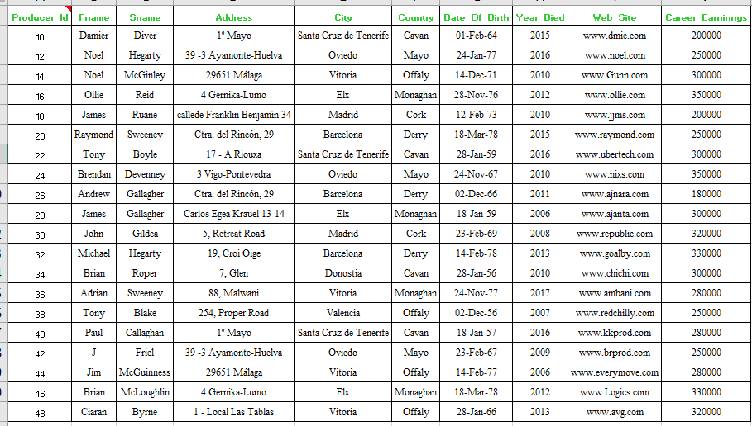

Film

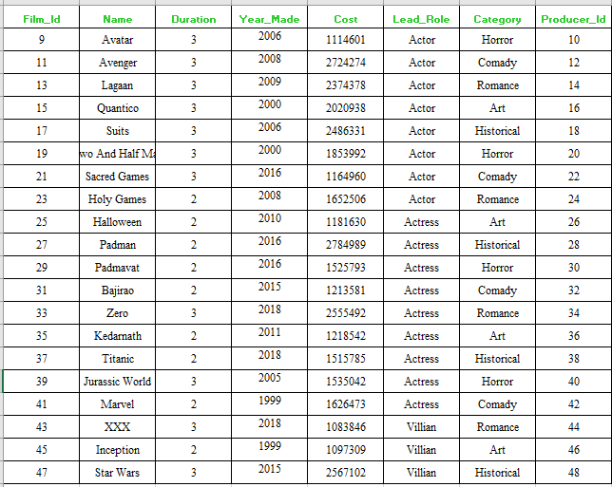

Critic

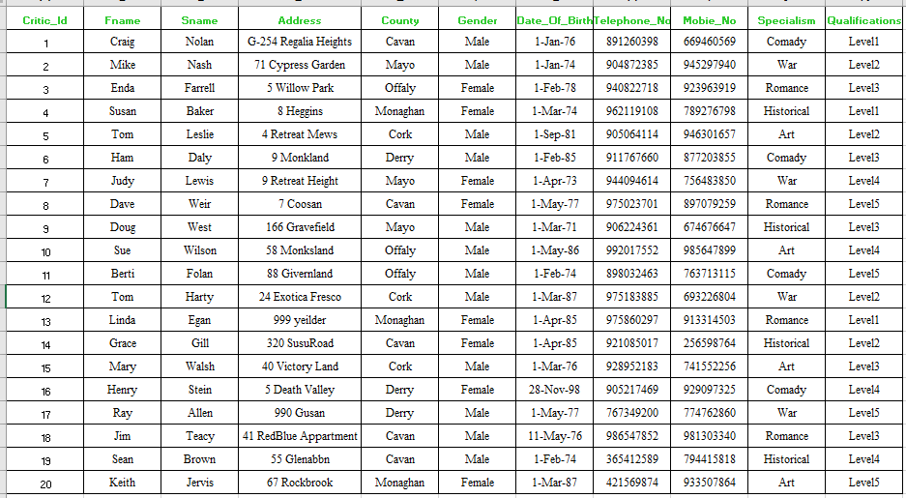

Cinema

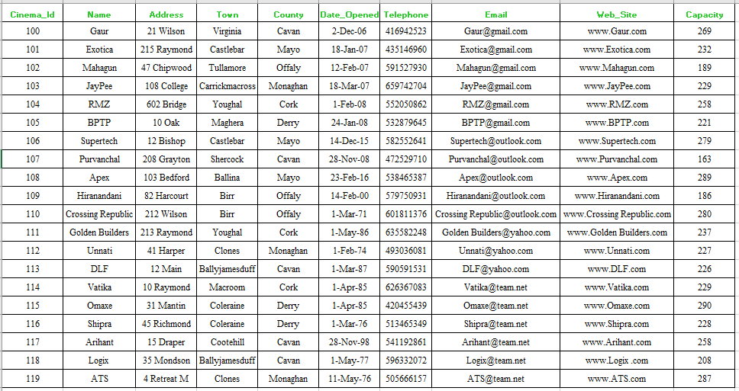

Review

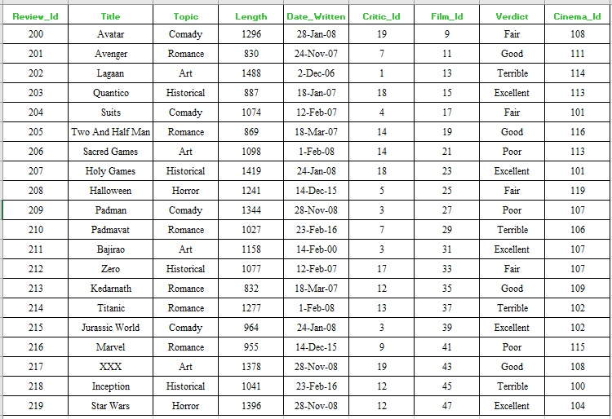

Publication

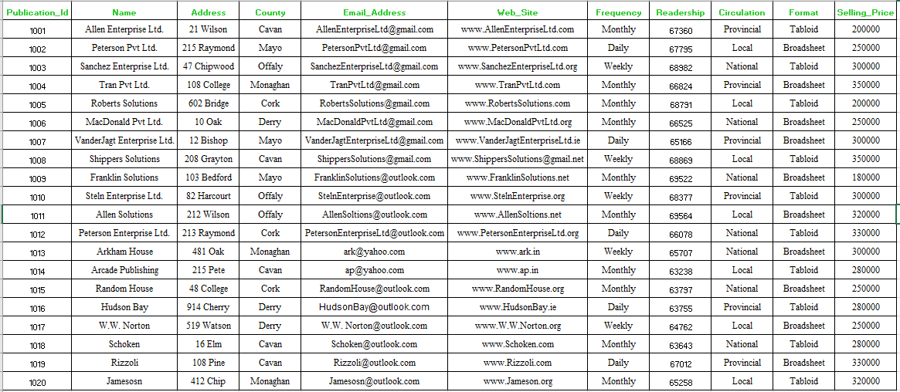

Review_Publication

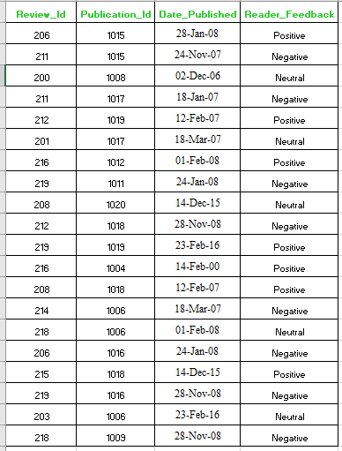

# 9. Normal Queries

**Q1) List the Fname, City, Country, Web_Site, and Year_Died of all the Producer who lives in Barcelona and Career_Earninngs is not more than 250000.** **Order the results by Name of Producer.**

Select Fname, City, Country, Web_Site, Year_Died

From Producer

Where City = 'Barcelona'

And Career_Earninngs <=250000

Order By Fname;

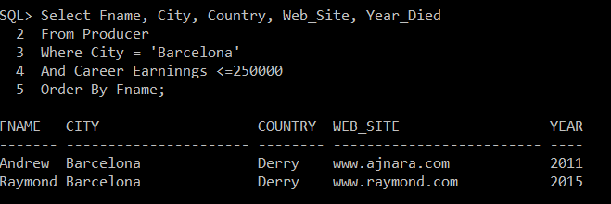

**Q2) List Fname,Sname, Address, County and Telephone_No whose Qualification is Level1 and Monaghan county and have Specialism is either Romance or Historical.**

Select Fname,Sname, Address, County, Telephone_No

From Critic

Where County = 'Monaghan'

And Specialism In ('Romance', 'Historical');

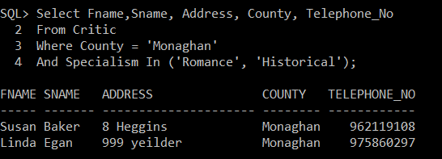

**Q3) List Name, Town, County, Capacity, Email of Cinema's having outlook in its email address and who has capacity more than 250.**

Select Name, Town, County, Capacity

From Cinema

Where Email Like ’%outlook%’

And Capacity > 250;

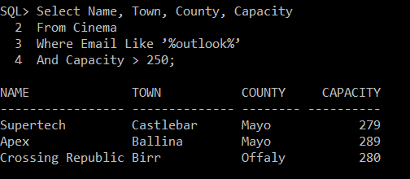

# 10.Joins

**Q4) List Fname, City, Country, Web_Site, and Year_Died of Producer who made a film of category Horror or Romance and Lead_Role played by an actress. Place the result in Order of Producer Name. Complete Query with Alias Name.**

Select P.Fname,P.City, P.Country, P.Web_Site, P.Year_Died

From Producer P, Film F

Where P.Producer_Id = F.Producer_Id

And F.Category In ('Horror', 'Romance')

And P.City In ('Barcelona', 'Madrid')

And F.Lead_Role = 'Actress'

Order By P.Fname;

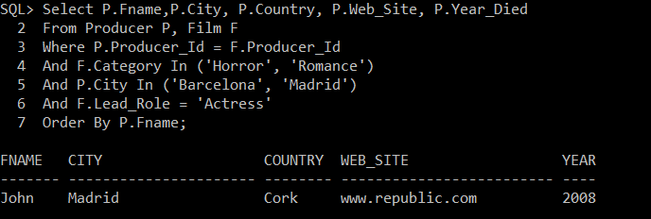

**Q5) List the producer Fname and Career_Earnnings pairs which have same city, same country, and same year_died.**

Select P1.Fname, P1.Career_Earninngs, P2.Fname, P2.Career_Earninngs

From Producer P1, Producer P2

Where P1.City = P2.City

And P1.Country = P2.Country

And P1.Year_Died = P2.Year_Died

And P1.Producer_Id > P2.Producer_Id;

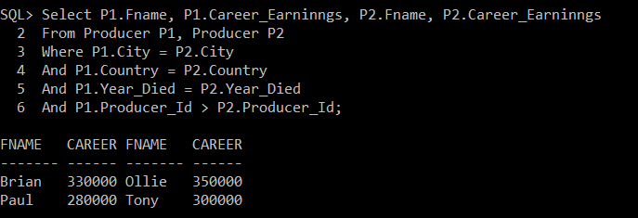

**Q6) List the name of Producer, name of film, name of critic, Cinema name, Publication Name, Review title, category of film, and year made of that film should not be null and producer must have career earnings not more than 250000. The cost of the film should be between 1000000 and 250000. Critic should be specialised in war, comedy or romance and Publication Circulation should ne national or Provincial and email of cinema should have gmail in it. Complete the query with alias names.**

Select P.Fname, F.Name, C.Fname, CN.Name, R.Title, F.Category, F.Year_Made,PB.Name, P.Career_Earninngs,F.Cost, Cn.Email, C.Specialism, PB.Circulation

From Producer P, Film F, Critic C, Cinema CN, Review R, Publication PB, Review_Publication RB

Where P.Producer_Id = F.Producer_Id

And F.Film_Id = R.Film_Id

And C.Critic_Id = R.Critic_Id

And CN.Cinema_Id = R.Cinema_Id

And R.Review_Id = RB.Review_Id

And PB.Publication_Id = RB.Publication_Id

And CN.Email Like '%gmail%'

And P.Career_Earninngs <= 250000

And F.Cost Between 1000000 And 2500000

And C.Specialism In ('Romance', 'War', 'Comady')

And PB.Circulation In ('Provincial', 'National')

And F.Year_Made Is Not Null;

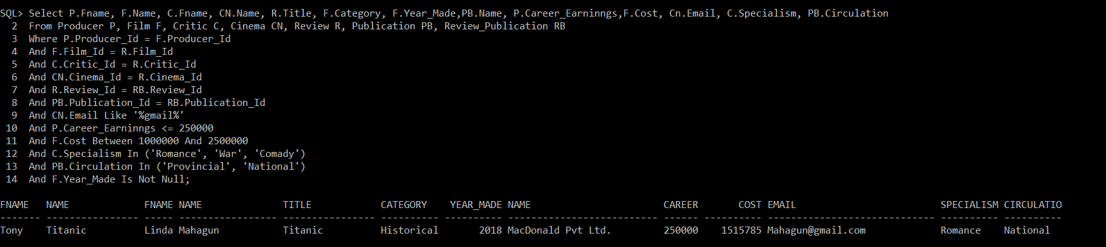

# 11. SubQueries

**Q7) Find out the 3 highest Career Earning producer**

SELECT *

FROM

(

SELECT Fname, Career_Earninngs, DENSE_RANK() OVER (ORDER BY Career_Earninngs DESC)

nth_highest_Career_Earninngs

FROM Producer

)

WHERE nth_highest_Career_Earninngs= 3;

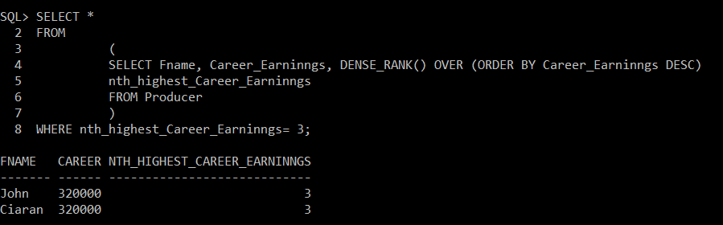

**Q8) List the name, circulation and format of publication whose selling price when doubled is less the cumulative total of Redearship and circulation is no other than NATIONAL and format should not be Tabloid. Arrange the result by name.**

Select Name, Selling_Price, Circulation, Format

From Publication

Where Selling_Price * 2<

(Select Sum(Readership)

From Publication)

And Circulation = 'National'

And Format <> 'Tabloid'

Order By Name;

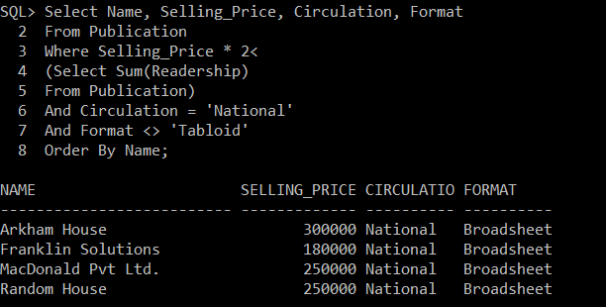

**Q9) List The Fname, City, Country and Career_Earnnings of producer Who does not belong to Barcelona city and who made a film before 2010 and category should be in Art or Romance. Complete the query with alias**

Select P.Fname, P.City, P.Country, P.Career_Earninngs

From Producer P

Where P.City <> ’Barcelona’

And P.Producer_Id In

(Select F.Producer_Id

From Film F

Where F.Year_Made< 2010

And F.Category In ('Art', 'Romance'));

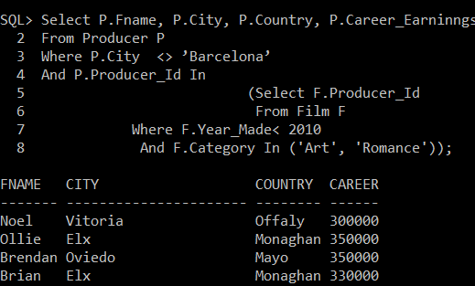

**Q10) List the Review Tittle, Topic and Date_Written whose length not less that 1000 for cinema who are located other the Derry and Cork and whose Critic is female and films whose name contains letter a and year made should be 2000 to 2008 for producer who city is other than Virginia. Arrange the query by title reverse order. Use the confined names wherever required.**

Select Title, Topic, Date_Written

From Review

Where Length >=1000

And Review.Cinema_Id In

(Select Cinema_Id

From Cinema

Where County Not In ('Derry', 'Cork'))

And Review.Critic_Id In

(Select Critic.Critic_Id

From Critic

Where Gender = 'Male')

And Review.Film_Id In

(Select Film.Film_Id

From Film

Where Name Like '%a%'

And Year_Made Between 2000 And 2008

And Film.Producer_Id In

(Select Producer.Producer_Id

From Producer

Where City <> 'Virginia'))

Order By Title Desc;

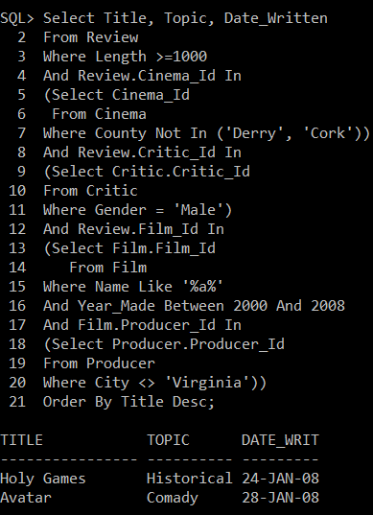

# 12. Summary Queries

**Q11) Give Maximum career earnings, minimum Career Earning and difference between maximum and minimum career earning with respect to Producer Fname. Arrange the results with reverse order of Fname**

Select Fname, Max(Career_Earninngs), Min(Career_Earninngs), Max(Career_Earninngs) - Min(Career_Earninngs) Difference

From Producer

Group By Fname

Order By Fname Desc;

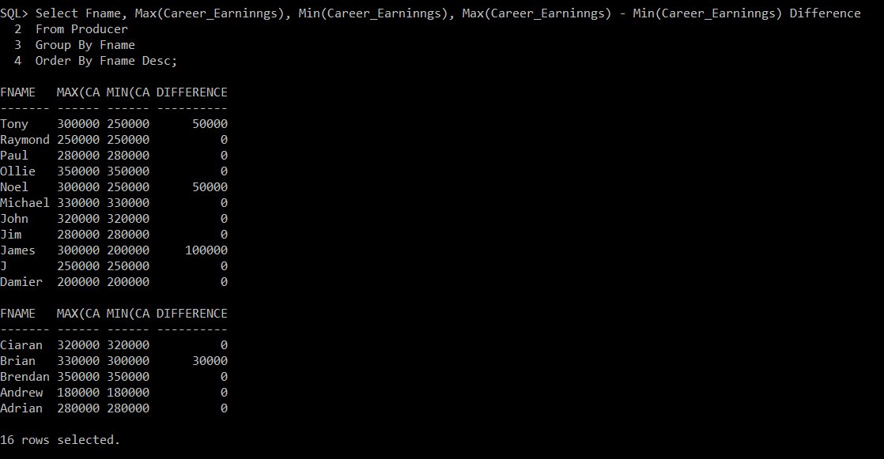

**Q12) Give Maximum career earnings, minimum Career Earning and difference between maximum and minimum career earning with respect to Producer Fname. Confine the results with maximum earning at least 200000. Arrange the results with reverse order of Fname**

Select Fname, Max(Career_Earninngs), Min(Career_Earninngs), Max(Career_Earninngs) - Min(Career_Earninngs) Difference

From Producer

Group By Fname

Having Min(Career_Earninngs) > 200000

Order By Fname Desc;

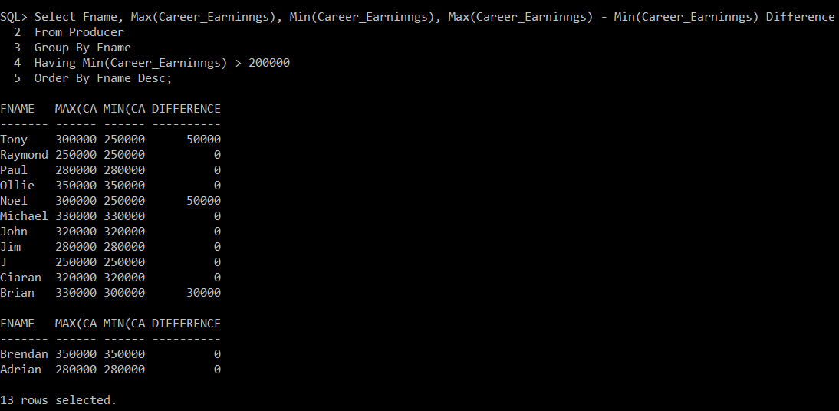

**Q13) Give Average, Minimum, Maximum Capacity for Cinema , where Cinema county is other than Cavan and Review Title which contain letter a in it and whose verdict is no other the Good Fair and Excellent. Complete the query with Table Aliases.**

Select Avg(C.Capacity), Max(C.Capacity), Min(C.Capacity)

From Cinema C, Review R

Where C.Cinema_Id = R.Cinema_Id

And C.County <> 'Cavan'

And R.Title Like '%a%'

And R.Verdict In ('Good', 'Fair', 'Excellent');

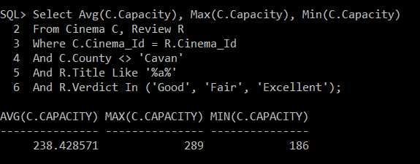

# 13. Correlated Subqueries

**Q14) Select the name and Country of producer where and who Year_Died before 2010 and produced the film.**

Select Fname, Country

From Producer

Where Year_Died < 2010

And Exists

(Select *

From Film

Where Producer.Producer_Id = Film.Producer_Id);

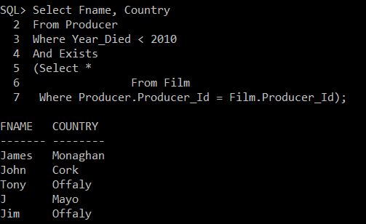

**Q15) List the cinema name, town, county where no other than Derry, Cavan, Cork and where no reviews are done.**

Select Name, Town, County

From Cinema

Where County In ('Derry', 'Cavan', 'Cork')

And Not Exists

(Select *

From Review

Where Cinema.Cinema_Id = Review.Cinema_Id);

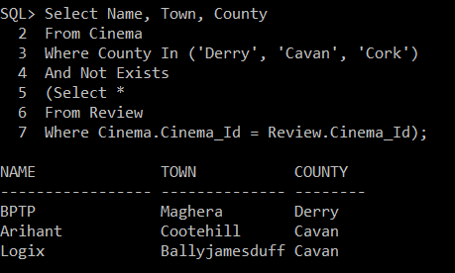

# 14 .Views

**Q16) Create a view to store the Fname, Sname, City, Country of pair of Pairs of producer who belongs to the same Country and in same city.**

Create View Producer_Details As

Select P1.Fname P1_F, P1.Sname P1_S, P1.City P1_City, P1.Country P1_Country, P2.Fname P2_F, P2.Sname P2_S, P2.City P2_City, P2.Country P2_Country

From Producer P1, Producer P2

Where P1.City = P2.City

And P1.Country = P2.Country

And P1.Producer_Id > P2.Producer_Id;

Select * from Producer_Details;

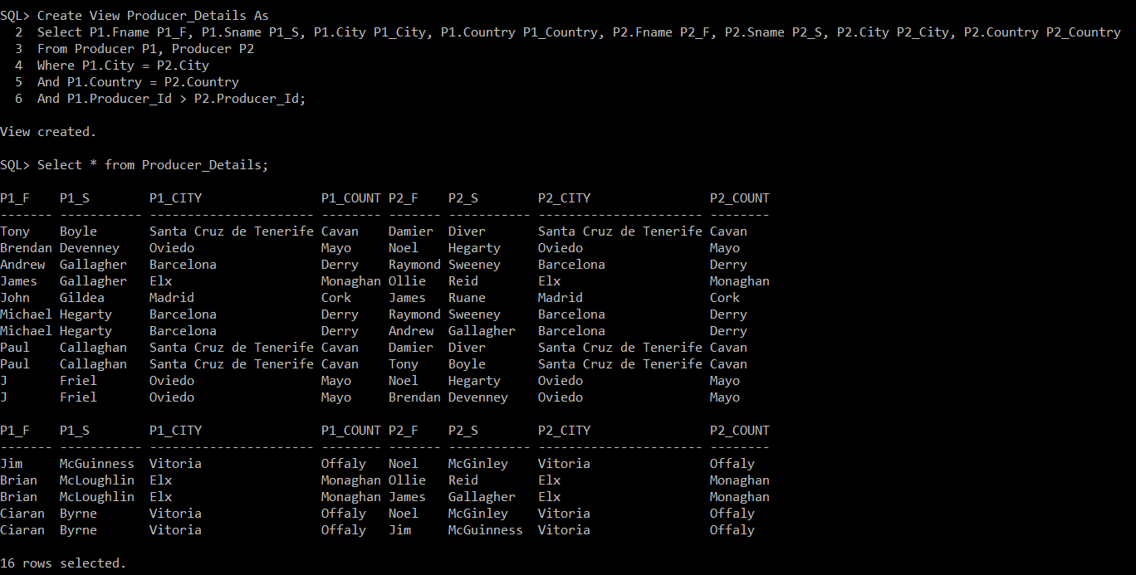

**Q17) Devise a view of Fname, Sname, City, Country of pair of Pairs of producer who belongs to the same Country and in same city.**

Create View RB_Details As

Select Title, Length, Date_Written, Name, County

From Review, Publication, Review_Publication

Where Review.Review_Id = Review_Publication.Review_Id

And Review_Publication.Publication_Id = Publication.Publication_Id

And Length > 1000

And Name Like '%h%';

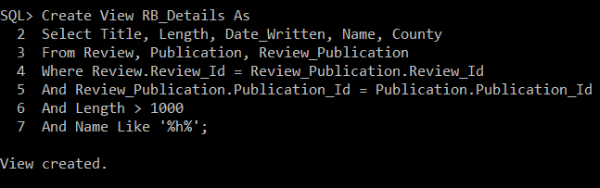

Select * from RB_Details;

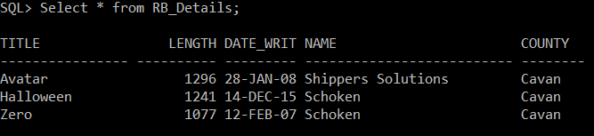

# 15.Union

**Q18) Select the Sname, Fname and Birth of Producer and Critics.**

Select Sname, Fname, Date_Of_Birth

From Producer

Where Fname Like 'C%'

Union

Select Sname, Fname, Date_Of_Birth

From Critic

Where Fname Like 'C%';

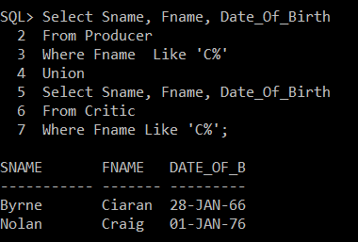

# 16. Updates

**Q19) We need to increase the capacity 25 of those Cinema email contain gmail and town is other than Virginia and who has been reviewed for the title which does contain letter a and has a verdict other than Fair and the Critic who did review is male and has specialism in Romance, War, Comady.**

Update Cinema

Set Capacity = Capacity + 25

Where Email Like '%gmail%'

And Town <> 'Virginia'

And Cinema_Id In

(Select Review.Cinema_Id

From Review

Where Review.Cinema_Id = Cinema.Cinema_Id

And Title Like '%a%'

And Verdict <> 'Fair'

And Review.Critic_Id In

(Select Critic.Critic_Id

From Critic

Where Review.Critic_Id = Critic.Critic_Id

And Gender = 'Male'

And Specialism In ('Romance', 'War', 'Comady')));

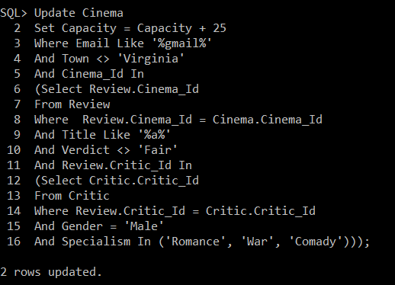

**Q20) Create a Query to provide ALL privileges to user for creating a view.**

Grant all privileges to WCL;

**We need to connect to SYSTEM user to grant privileges to the user.**

**Incase account gets lock following command can be used to unlocking the account**

Connect SYSTEM as SYSDBA

sys_password

alter user SYSTEM identified by Rathi account unlock;